Purpose:
Provide a structured technique for facilitating analysis of risk, and then documenting the results of the analysis. RAT Worksheets can be modified over time, and the versioning history will show trends in risk, probability, and mitigation actions.

Summary:
This package is a stand-alone solution. Each risk analysis tool has 1 or more worksheets for documenting risk elements and their consequences. Since RAT’s are integrated within Aras Innovator, normal team collaboration, reporting and workflow functions can be used to discover and mitigate risk.

Screenshot of the TOC Risk column
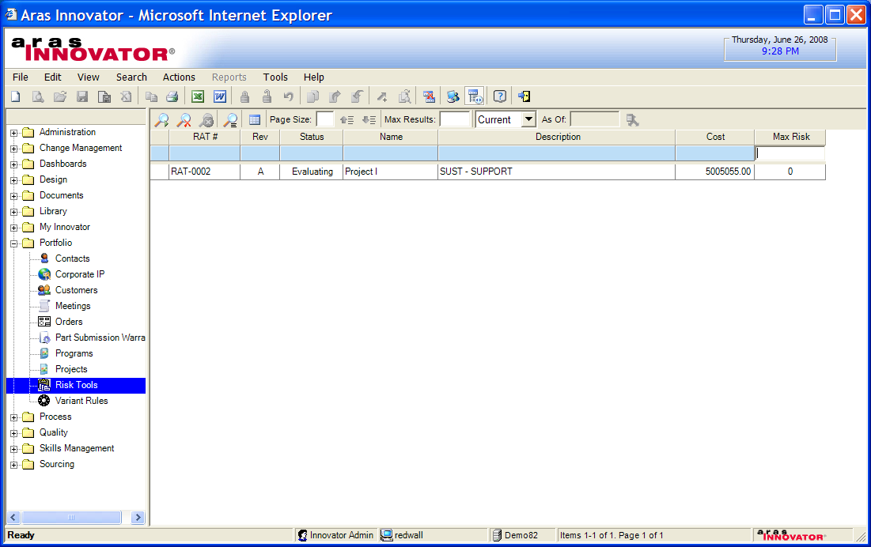

For each RAT workbook, there is a tab of Worksheets. Each worksheet covers one risk element and it’s associated notes, mitigation, and consequences. The worksheet is represented with a 5x5 graphic, and the workbook has a rollup 5x5 graphic representing the summary of all the worksheets.

Screen shot of the RAT showing the Worksheets Tab
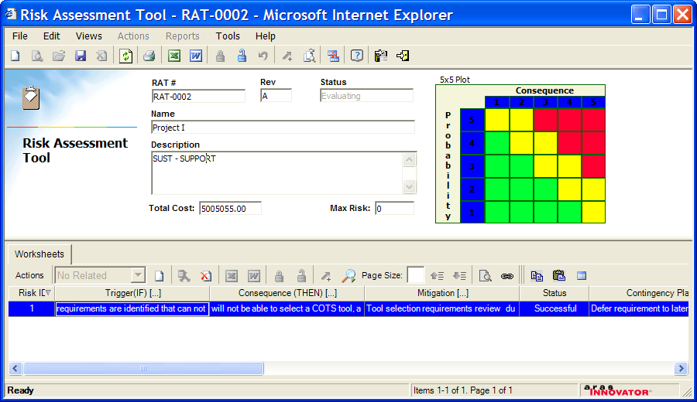

Screen Shot of a Single Worksheet
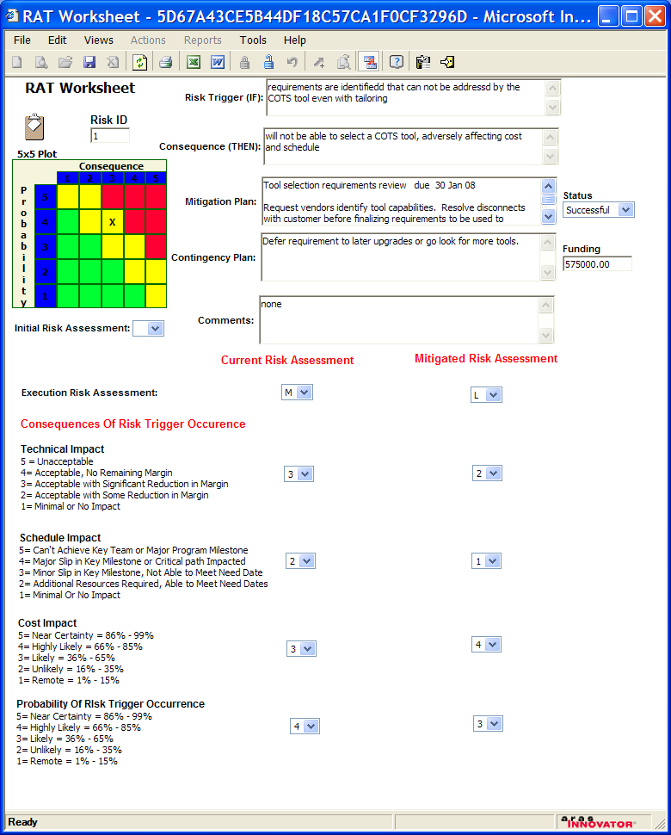

Still to-do:
- Add Action items and workflows at the Worksheet level
- Lifecycle logic for Baselining is not implemented yet

Peter Schroer
pschroer@aras.com

